**Labor Cost Analysis - Manufacturing Sector**

GOKULNATH K & E24755

**Overview**

Labor cost analysis in manufacturing involves evaluating the total expenses related to wages, benefits, and other employee-related costs. It aims to identify trends, inefficiencies, and areas for cost optimization. Data analysis helps in tracking labor hours, productivity, and comparing labor costs against production output. This insight supports decision-making for budget allocation, process improvements, and workforce management.

**Objective**

1. **Cost Optimization:** Identify areas to reduce labor costs without compromising productivity or quality.
2. **Efficiency Improvement:** Analyze labor hours, workforce allocation, and performance to improve operational efficiency.
3. **Budget Allocation:** Provide data-driven insights for better budget planning and resource allocation for labor-related expenses.
4. **Productivity Tracking:** Measure workforce productivity relative to production output to ensure optimal labor utilization.
5. **Cost Benchmarking:** Compare labor costs with industry standards and internal goals to evaluate competitiveness.
6. **Forecasting and Planning:** Predict future labor needs and costs based on production trends and workforce data.

**Assigned Task(s)**

* Labor Cost Analysis - Manufacturing Sector

**Task Details**

* **Task 19:** The labor cost in manufacturing is the total amount spent on workers by the company. It includes not only wages but also contract workers costs, taxes of labor costs, bonuses, and other costs such as employee compensation schemes.
* **Status:** Completed
* **Details:** The dataset for labor cost analysis in the manufacturing sector, simulating employee details, wage and salary information, time tracking, production metrics, benefits, and cost allocations. It creates comprehensive data on employee roles, compensation, work hours, and production output. The dataset includes insights into labor costs distributed by the department and various benefits. Visualization examples include distributions, correlations, and time series analysis to explore labor costs and related metrics.

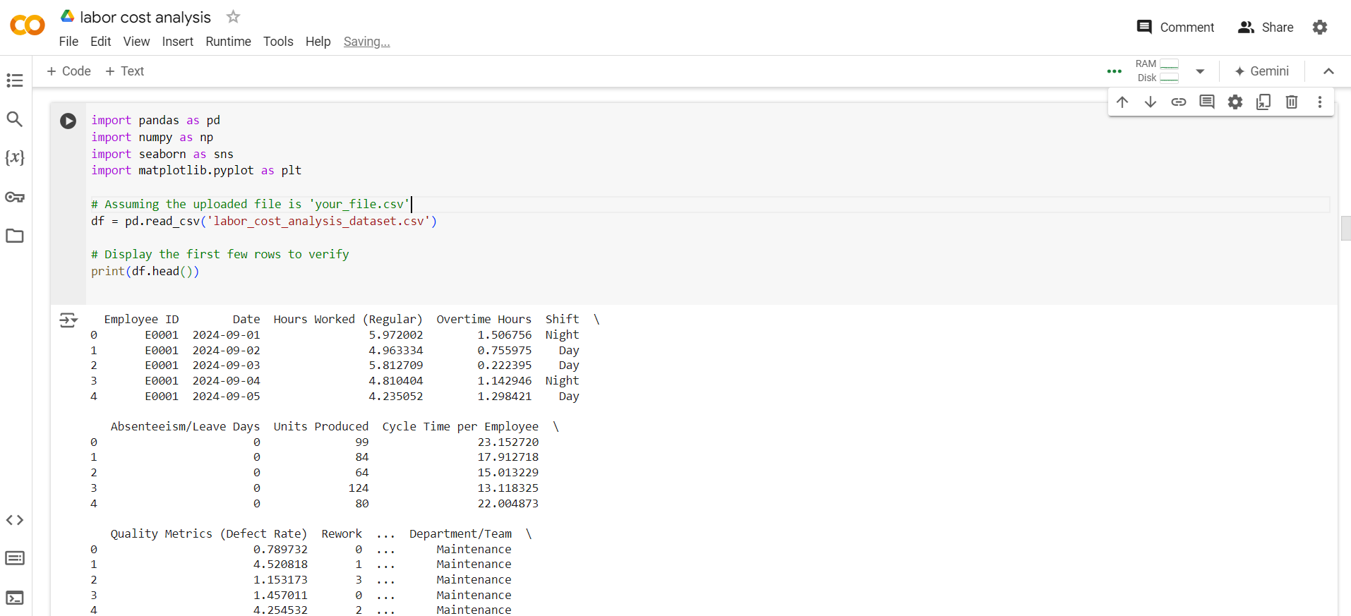

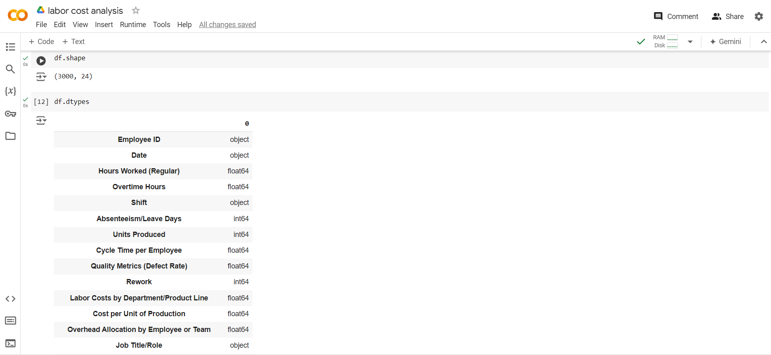

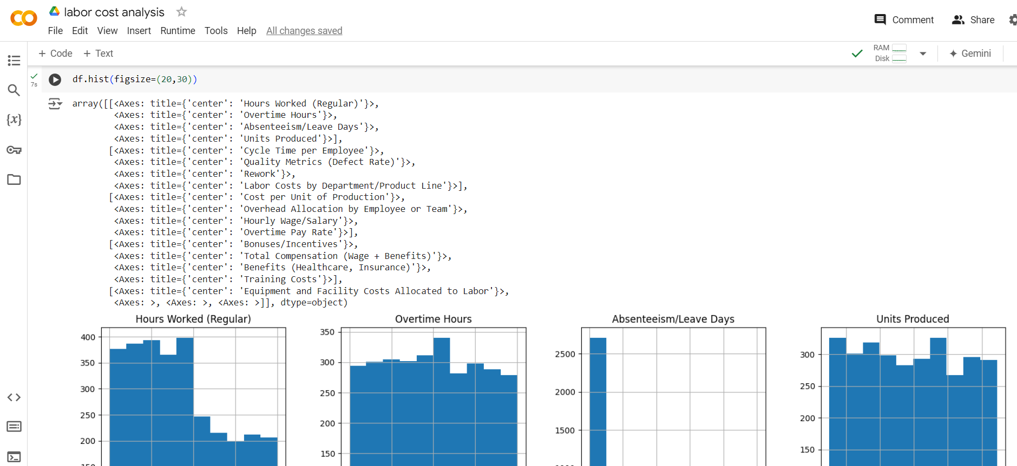

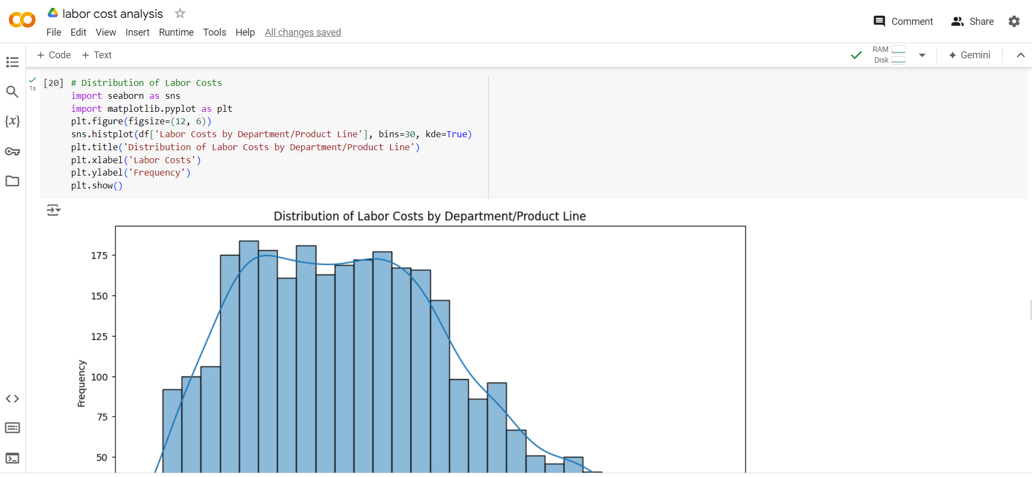

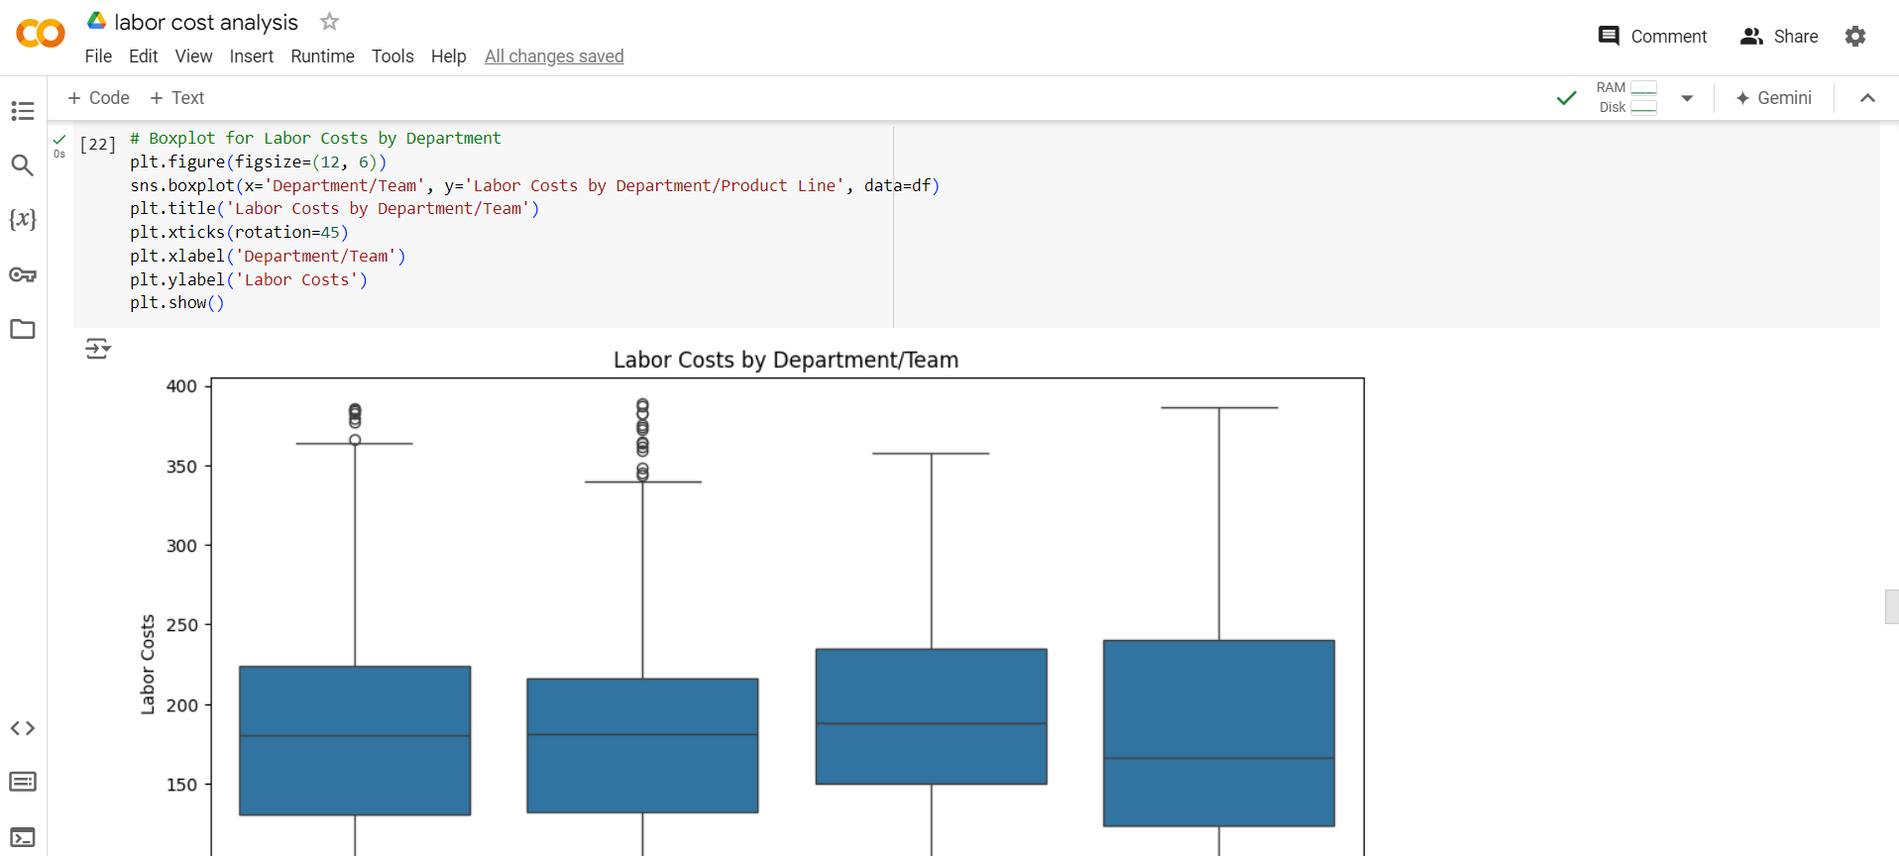

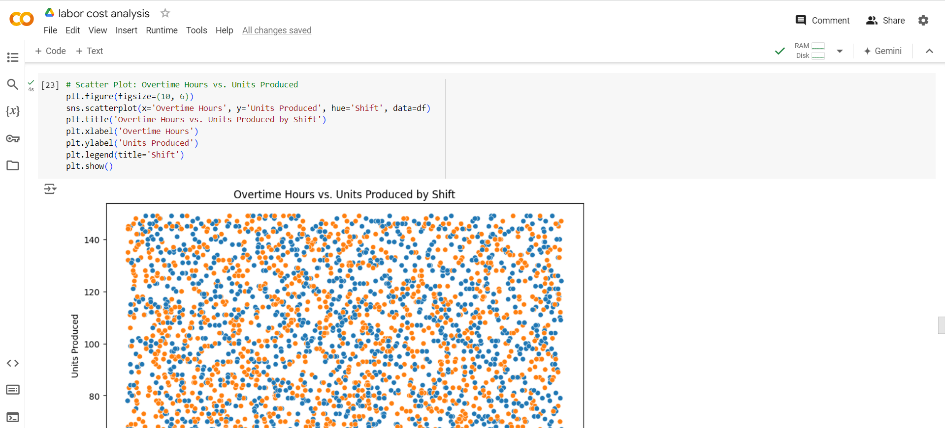

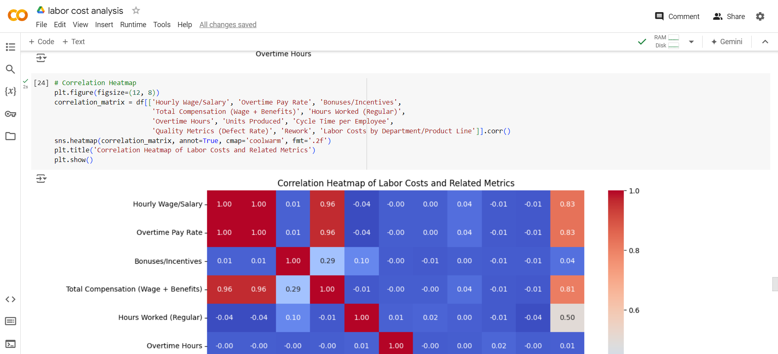

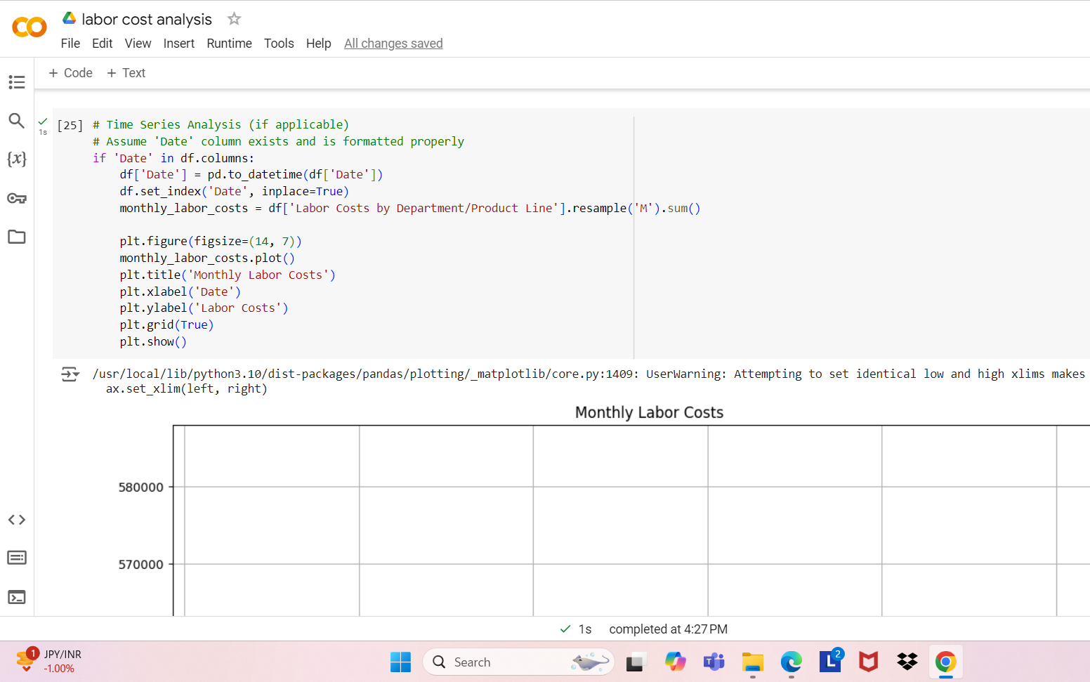

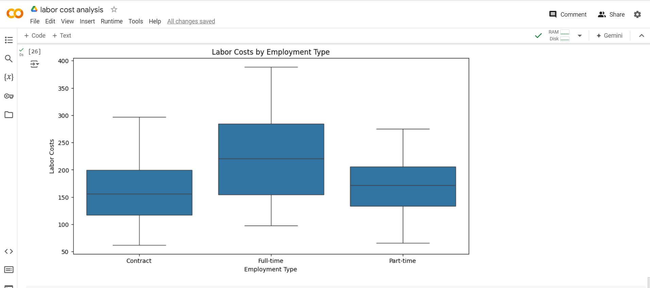

**Progress**

* **Accomplishments:** The accomplishments include creating a detailed synthetic dataset for labor cost analysis, encompassing employee roles, compensation, and time tracking. The dataset enables analysis of labor costs across departments and shifts, as well as examination of benefits and overheads. Visualizations provided include cost distributions, correlations, and time series trends, facilitating in-depth insights into labor cost dynamics. This comprehensive analysis supports data-driven decision-making and cost management strategies in the manufacturing sector.
* **Metrics:** The report will highlight key metrics including the total labor costs by department or product line, which illustrates expenditure across various organizational units. It will also cover the cost per unit of production, providing insights into labor efficiency and cost management. Additionally, the relationship between overtime hours and production output will be examined to assess productivity. Finally, a detailed breakdown of benefits and overheads, such as healthcare, training, and equipment costs, will offer a comprehensive view of non-wage expenses.

**Challenges and Solutions**

* **Challenges Faced:** Challenges encountered in this task include ensuring the accuracy and completeness of the generated data to reflect real-world scenarios effectively. Integrating diverse data sources into a unified dataset can be complex and time-consuming. Managing and analyzing large datasets may pose performance issues, particularly when examining intricate relationships. Additionally, creating clear and informative visualizations that convey insights without overwhelming the audience requires careful consideration and design.
* **Solutions Implemented:** To address these challenges, validate the generated data by cross-referencing with real-world examples to ensure accuracy. Use structured data merging techniques and maintain consistent formats for effective integration. Optimize data processing and utilize efficient tools to manage large datasets. For visualizations, focus on clarity and simplicity, with clear labels and contextual explanations to ensure insights are easily understood.

**Next Steps**

* **Upcoming Tasks:** To tackle upcoming tasks, prioritize clear goal-setting and efficient planning to stay organized and focused. Leverage available tools and data insights to address challenges proactively and adapt as needed.
* **Goals:** Set clear goals by defining specific, measurable objectives related to labor cost analysis, such as improving cost efficiency or identifying key cost drivers. Break these objectives into actionable tasks with deadlines to ensure focused progress and effective tracking.

**Conclusion**

* **Summary:** The labor cost analysis provides valuable insights into cost distribution, efficiency, and productivity by integrating comprehensive data on employee roles, compensation, and production metrics. Effective visualization and data management enable informed decision-making and strategic cost management in the manufacturing sector.
* **Acknowledgments:** Thank you all for your attention and engagement. Your interest and participation are greatly appreciated, and I hope the insights shared will be valuable for your work.